SiteSync Interface Requirements

**Exports to CSV**

Select Meter(s)  
Select start date  
Select finish date  
Select Data Type (Raw Meter Readings or Consumption)  
Select interval (15min, hourly, Daily, Monthly (only show complete months),

**Example Charts to be displayed on UI**

Daily Consumption Chart using Hourly Consumption data

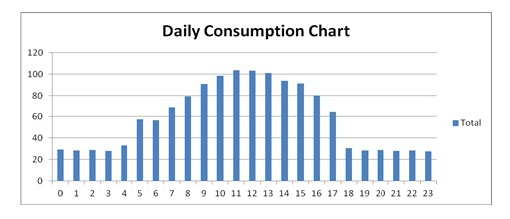

Monthly Consumption Chart using Daily Consumption data

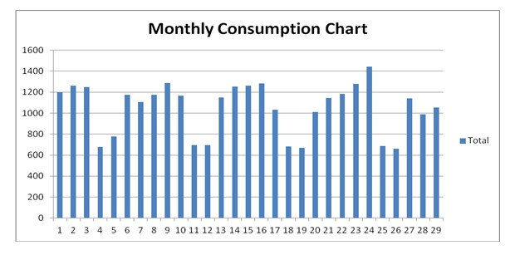

Weekly Consumption Chart using Hourly Consumption data (multiple meters)

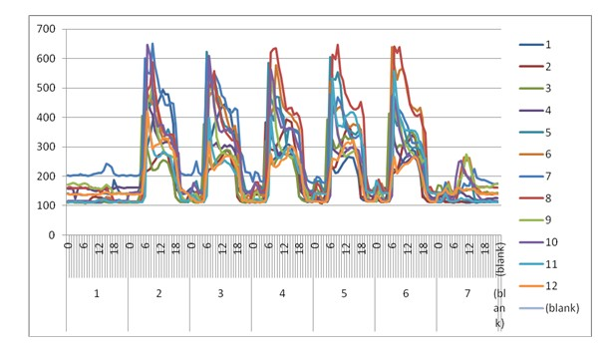

Year on Year Chart using Monthly Consumption data.

(No example available)